- Copyright for test papers and marking guides remains with West Australian Test Papers.
- The papers may only be reproduced within the purchasing school according to the advertised conditions of sale.
- Test papers must be withdrawn after use and stored securely in the school until 14th October.

HUMAN BIOLOGY
UNITS 3 & 4
2021

Name: ________________________________SOLUTIONS

Teacher: ___________________________________________________

Time allowed for this paper

Reading time before commencing work: ten minutes
Working time: three hours

Materials required/recommended for this paper
To be provided by the supervisor
This Question/Answer booklet
Multiple-choice answer sheet

To be provided by the candidate
Standard items: pens (blue/black preferred), pencils (including coloured), sharpener, correction fluid/tape, eraser, ruler, highlighters

Special items: up to three calculators, which do not have the capacity to create or store programmes or text, are permitted in this ATAR course examination

Important note to candidates
No other items may be taken into the examination room. It is your responsibility to ensure that you do not have any unauthorised material. If you have any unauthorised material with you, hand it to the supervisor before reading any further.

Section One: Multiple-choice 30% (30 Marks)

Question Number | Solution
1 | D
2 | B
3 | D
4 | C
5 | B
6 | C
7 | A
8 | C
9 | C
10 | C
11 | B
12 | A
13 | D
14 | B
15 | D
16 | A
17 | C
18 | B
19 | C
20 | B
21 | B
22 | C
23 | A
24 | A
25 | D
26 | D
27 | D
28 | B
29 | B
30 | A

Section One: Multiple-choice 30% (30 Marks)

This section has 30 questions. Answer all questions on the separate Multiple-choice answer sheet provided. For each question shade the box to indicate your answer. Use only a blue or black pen to shade the boxes. Do not use erasable or gel pens. If you make a mistake, place a cross through that square, then shade your new answer. Do not erase or use correction fluid/tape. Marks will not be deducted for incorrect answers. No marks will be given if more than one answer is completed for any question.

Suggested working time: 40 minutes.

1. The nervous system typically

(a) operates at a slower pace than the endocrine system.
(b) is more persistent than the endocrine system.
(c) affects more target cells at one time than the endocrine system.
(d) has shorter response times than the endocrine system.

2. Pressure on the skin would be carried through the

(a) efferent nervous system.
(b) somatic nervous system.
(c) autonomic nervous system.
(d) sympathetic nervous system.

3. A person was diagnosed with hypothyroidism and was treated by having her thyroid gland removed. In this case, which of the following would be correct? After surgery,

(a) less thyroid stimulating hormone (TSH) would be produced.
(b) more TSHrf would be released from the posterior pituitary.
(c) her metabolic rate would increase.
(d) she would need to take a synthetic hormone that mimics thyroxine.

4 Which of the following statements is correct?

(a) Parathyroid glands release prolactin.
(b) Cortisol is produced by the adrenal medulla.
(c) The thymus and pineal glands are both endocrine glands.
(d) Noradrenaline slows heart rate.

5. Vesicles in the axon terminals

(a) move towards the presynaptic membrane because sodium moves into the neuron.
(b) store neurotransmitters.
(c) release neurotransmitters into the synapse through diffusion.
(d) move across the synapse towards the receptors on the post synaptic dendrite.

6. The central nervous system is believed to use approximately 20% of all the body’s energy. Below is a list of events that occur during the transmission of a nerve impulse across a synapse.

i) reuptake of acetylcholine
ii) production of neurotransmitters
iii) diffusion of neurotransmitters
iv) exocytosis
v) neurotransmitter connects with receptors

Which of these events would require energy?

(a) ii), iii) and v) only
(b) ii), iv) and v) only
(c) i), ii) and iv) only
(d) i), ii) and iii) only

7. Following is a list of events that occur to prevent antigens from causing us harm.
i) core body temperature rises
ii) phagocytosis occurs
iii) cilia move in a wavelike pattern
iv) blood vessels dilate
v) sebum is released

Which of these events would occur as part of a non-specific internal response to an antigen?

(a) i), ii), and iv) only
(b) i), ii), and iii) only
(c) ii), iii) and iv) only
(d) ii), iv) and v) only

8. Alzheimer’s

(a) and Parkinson’s are both good candidates for gene therapy as a treatment.
(b) is due to a decrease in dopamine at the synapse.
(c) could be treated with cell replacement therapy if the issue of access can be overcome.
(d) requires the correct gene to be inserted into cells using recombinant DNA technology.

Questions 9, 10 and 11 refer to the following information.

The DNA of three fossils was compared using gel electrophoresis and the results are shown below.
End 1 End 2
Fossil X

Fossil Y

Fossil Z

9. End 1 of the agarose gel

(a) is where the positive electrode is.
(b) is where the largest pieces of DNA would be found after the gel is run.
(c) is where the DNA is placed into the gel.
(d) would have the red electrode on its side.

10. According to the gel shown above,

(a) Fossil Y and Fossil Z are most closely related.
(b) Fossil Z has the longest pieces of DNA.
(c) Fossil X and Fossil Y are most closely related.
(d) Fossil Y has the shortest pieces of DNA.

11. Prior to being placed on the gel, all three samples of DNA would have been

(a) treated with DNA ligase.
(b) amplified using a polymerase chain reaction.
(c) cut using different restriction enzymes.
(d) inserted into a plasmid.

12. All of the following are ways in which T cells and B cells are similar, except one. Which one is incorrect?

(a) An antigen is presented to both of them by a macrophage.
(b) They both originate in bone marrow.
(c) They both act against only one particular type of antigen.
(d) When in contact with an antigen they recognise, they both activate and divide.

13. Cerumen and histamine are both

(a) part of the body’s external immune response.
(b) involved in the inflammatory response.
(c) released during a fever.
(d) part of the body’s non-specific immune response.

Questions 14 and 15 refer to the images (which are not to scale) and information below.

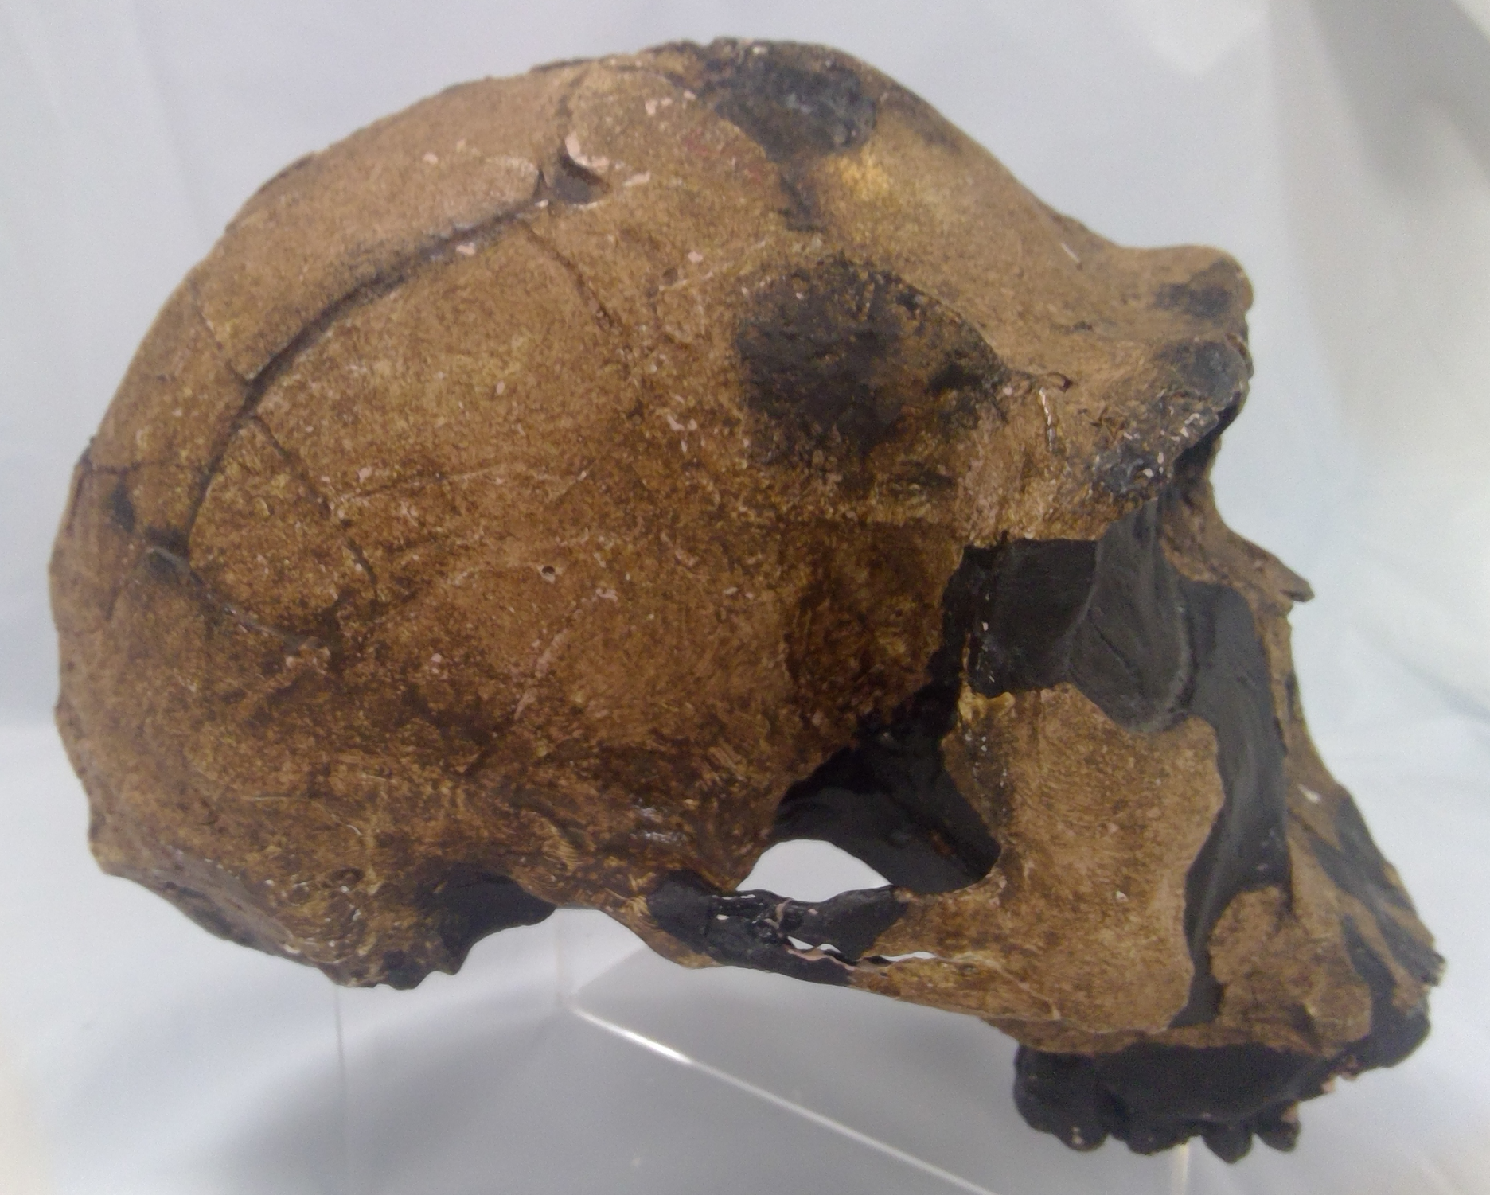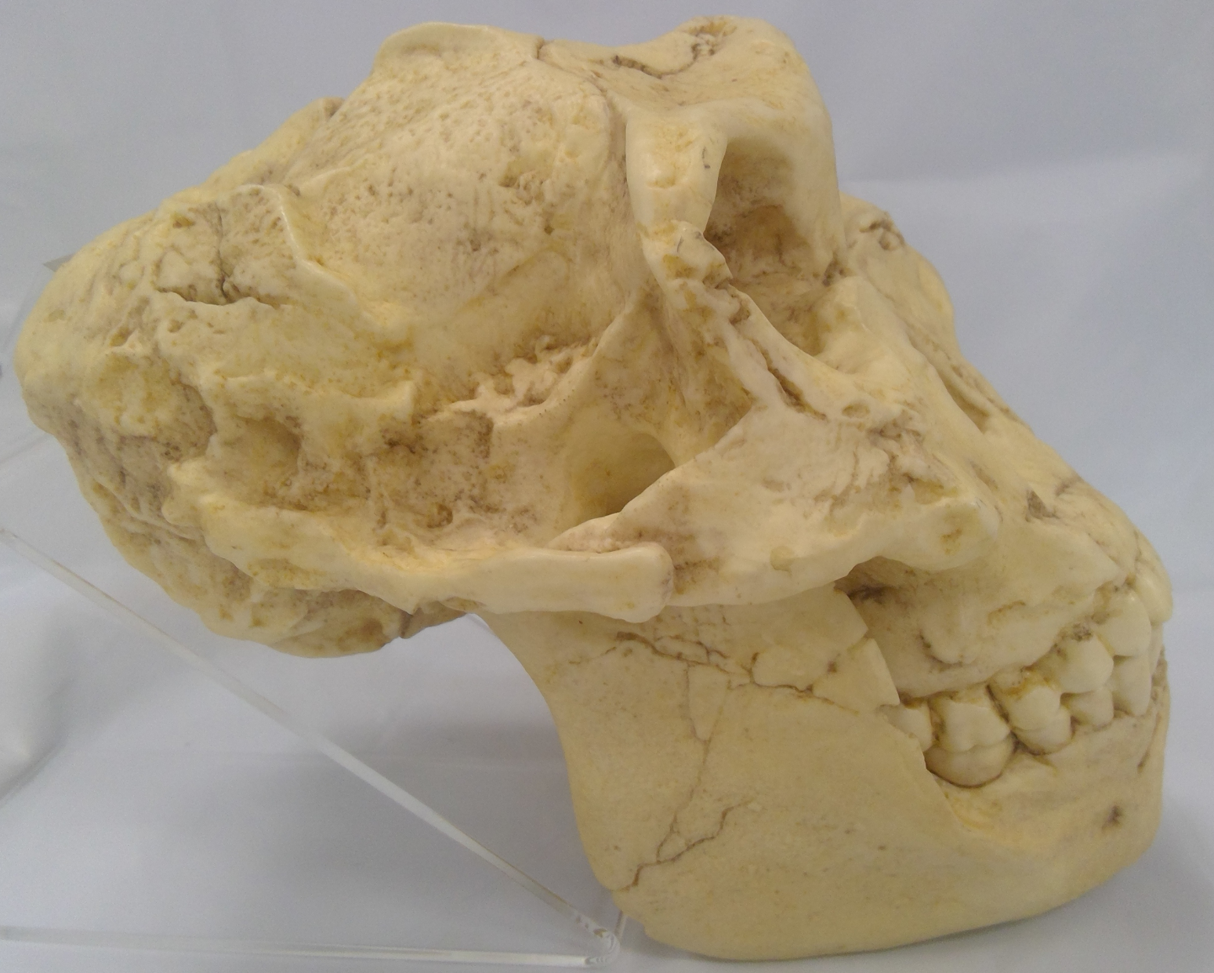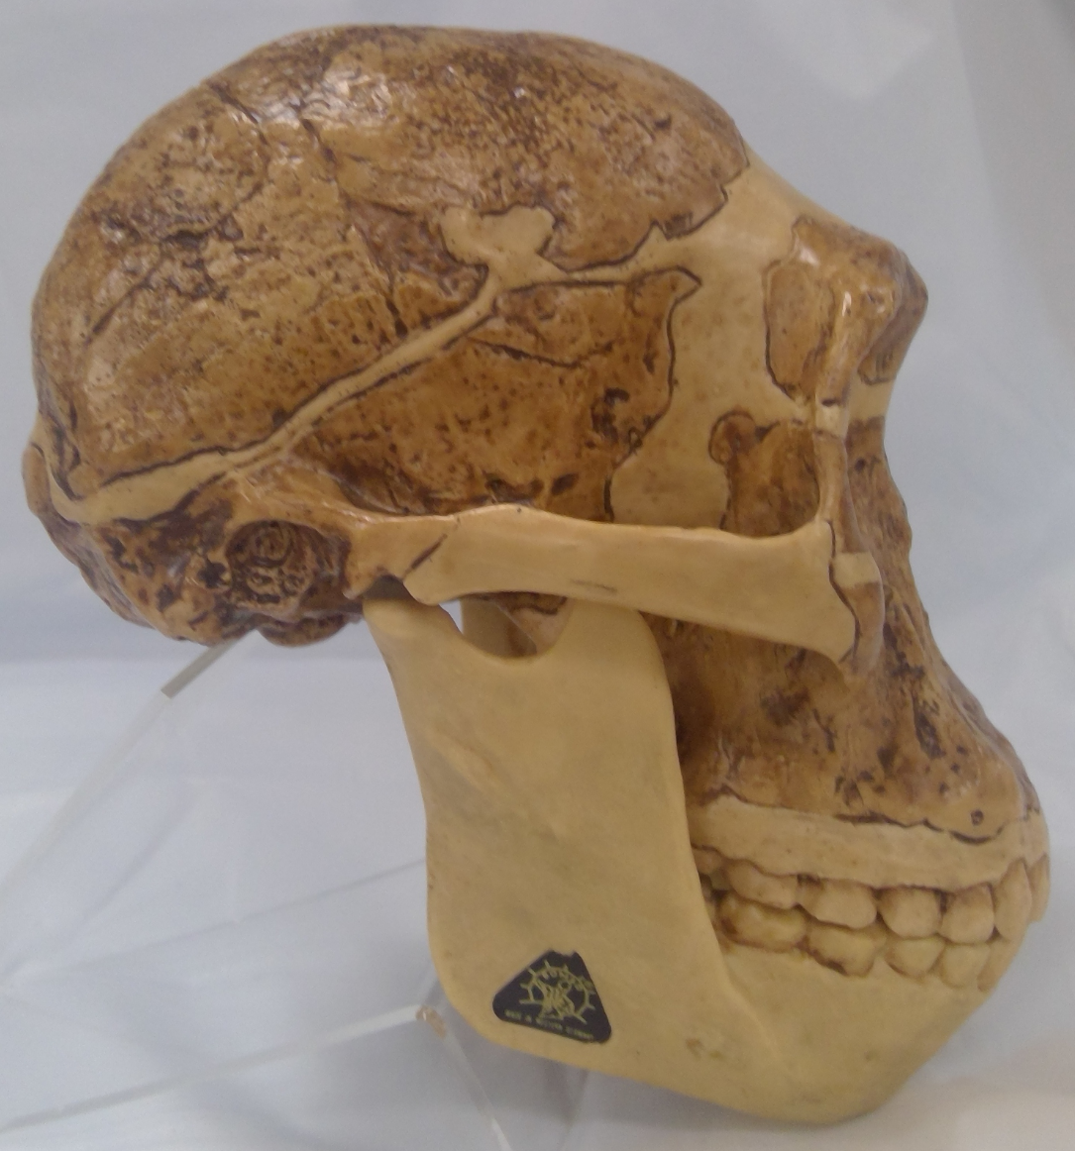
Species 1 Species 2 Species 3

Species 1 was found with stone tools and had a cranial capacity of approximately 1100cc.
Species 2 and 3 were found in South Africa.

14. Which of the following statements is incorrect?

(a) Species 1 is Homo erectus.
(b) Species 3 is believed to have made its own tools.
(c) Each of the three skulls belong to a different genus.
(d) Species 2 is not believed to be an ancestor of hominins.

15. Species 2 and 3

(a) each have an average cranial capacity of approximately 500cc.
(b) used fire.
(c) used tools in their day to day life.
(d) were both herbivores.

16. All of the following statements about index fossils are true, except one. Which one is incorrect?

(a) They can only be used if they are in the one location
(b) They should be found in a wide variety of geographical places
(c) They should be spread over a short period of time
(d) Pollen are good examples

Question 17 refers to the image below.

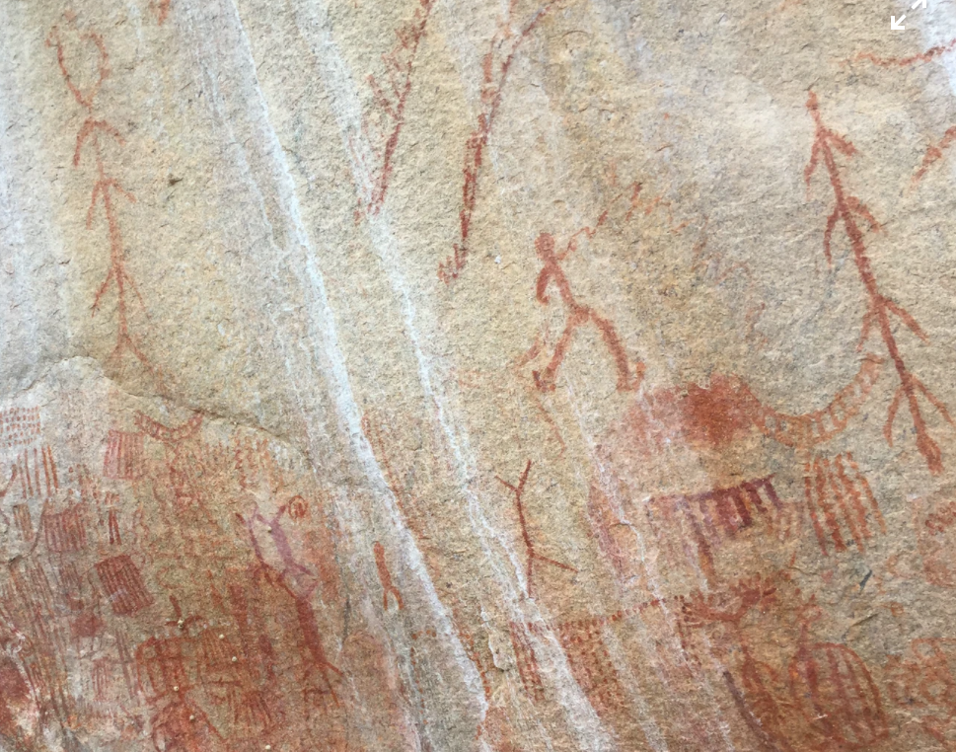

17. Cave art is first associated with

(a) Homo erectus.
(b) Homo habilis.
(c) Homo sapiens.
(d) Homo neanderthalensis.

Question 18 refers to the image of two fossils below.

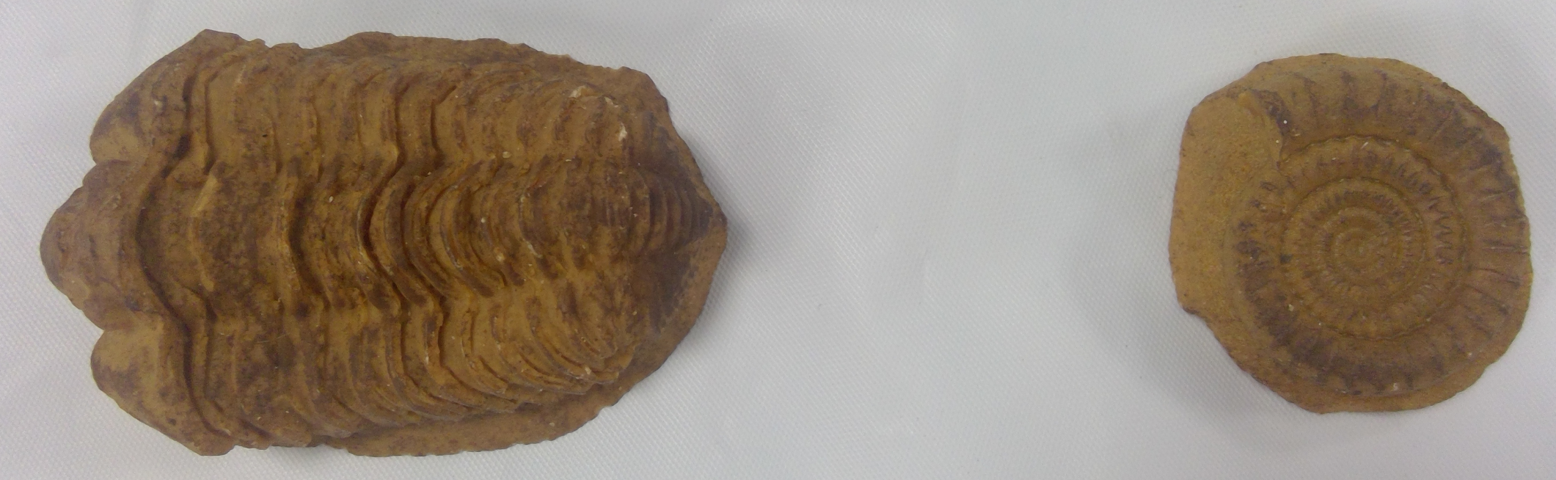

18. Below is a list of conditions that can occur after an organism has died.

i) sedimentary soil is present
ii) bacteria are present
iii) lack of oxygen available
iv) scavengers present
v) rapid burial
vi) acidic soils
vii) hot dry air

Which of these conditions would have prevented these fossils from forming?

(a) ii) and iv) only
(b) ii), iv) and vi) only
(c) iii) and vi) only
(d) iii), vi) and vii) only

Questions 19 and 20 refer to the images of lower jaws (not to scale) below.

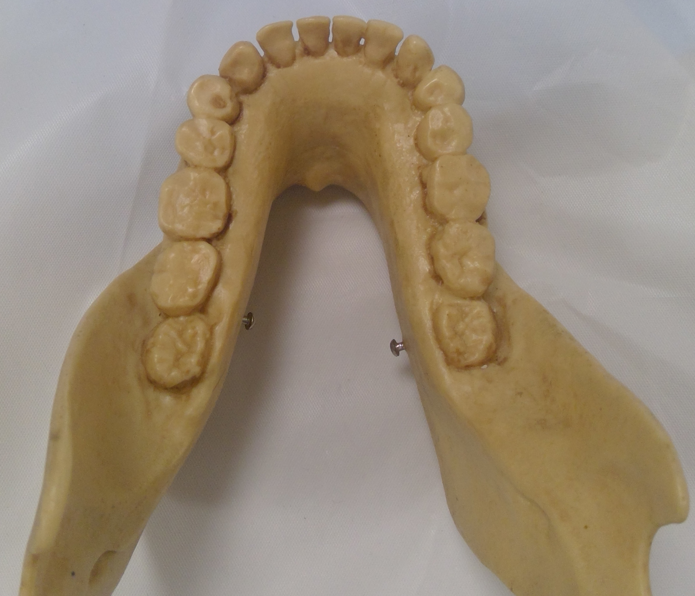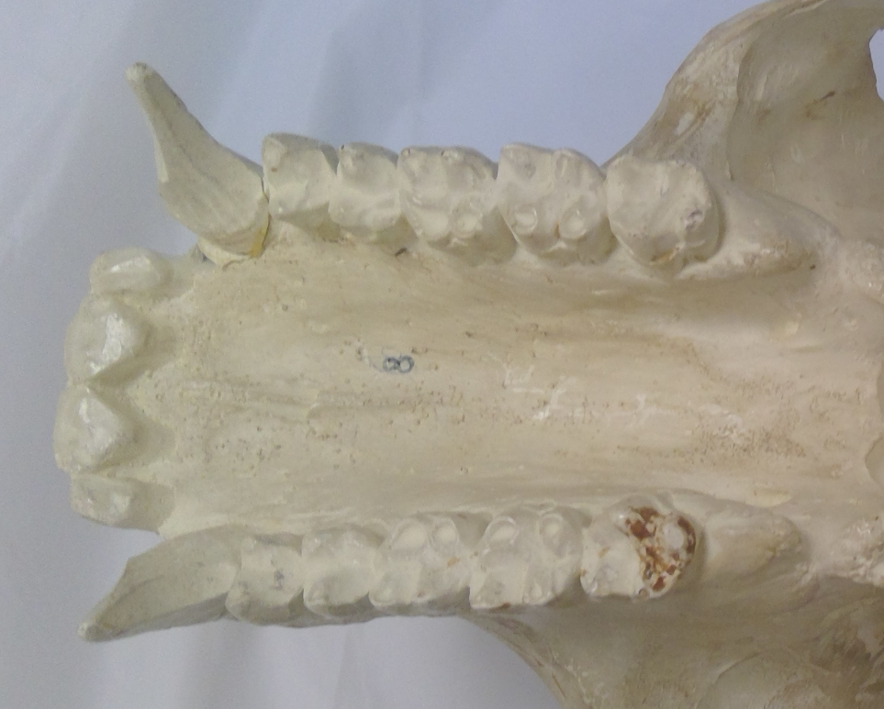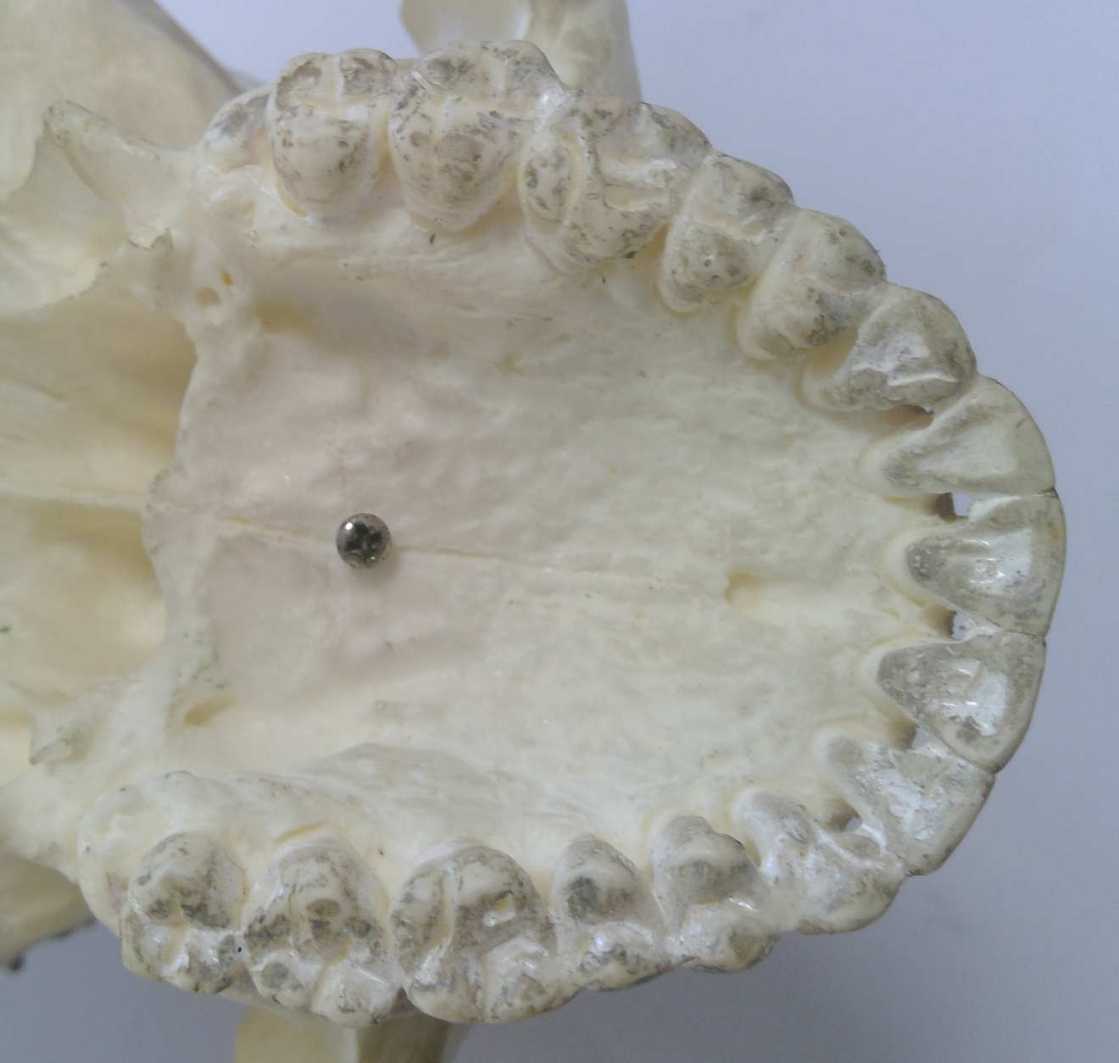
Jaw 1 Jaw 2 Jaw 3

19. Which of the following statements is correct?

(a) Jaw 1 belongs to Homo neanderthalensis.
(b) Jaw 1 belongs to Australopithecus afarensis.
(c) Jaw 2 belongs to a great ape such as Gorilla gorilla.
(d) Jaw 2 belongs to Paranthropus robustus.

20. The species that Jaw 3 has been taken from

(a) shows increased prognathism.
(b) is associated with an omnivorous diet.
(c) shows molars with a 4-cusp pattern.
(d) is an Australopithecine.

Questions 21 and 22 refer to the information below.

Figure 1 shows where one plasmid can be cut by 5 different restriction enzymes (M, N, O,
P and Q). The distance between these cutting sites is shown in base pairs (bp).

The plasmid was cut using only three restriction enzymes and the resulting fragments were separated by gel electrophoresis. The position of the fragments in the gel is shown next to a base pair ruler in Figure 2 below.

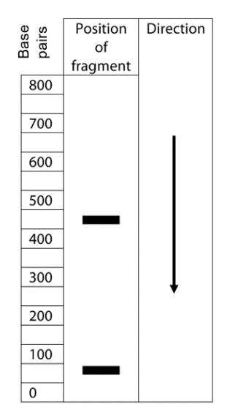
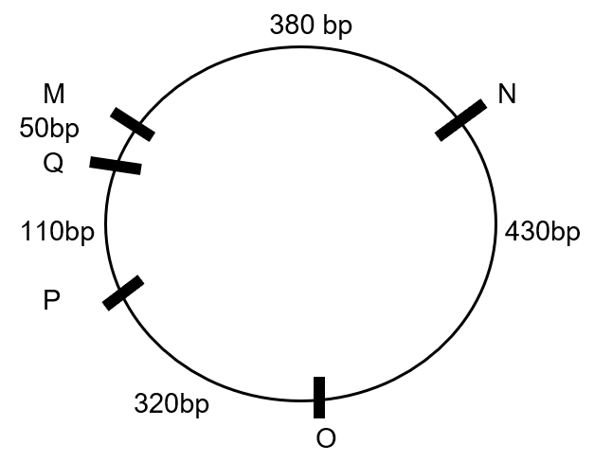
Figure 1 Figure 2

21. The restriction enzymes that were used to cut the plasmid were

(a) M, N and O.
(b) O, Q and M.
(c) O, P and Q.
(d) N, M and Q.

22. A number of plasmids from one bacterium were cut with restriction enzyme N. When a chemical was added to help join the cut sections back together again, not all plasmids were of the same size. This would be because

(a) not all plasmids would have been cut.
(b) not all plasmids would have re-joined.
(c) cut pieces could have joined up to other cut plasmids.
(d) their recognition sites are different in different plasmids.

Questions 23 and 24 refer to the following table which shows the temperatures (ºC) required to separate hybrid DNA of four different species.

 | E | F | G | H
E | 85 | 84 | 80 | 81
F |  | 86 | 81 | 80
G |  |  | 85 | 84
H |  |  |  | 86

23. Heat is used in order to

(a) denature the double helix of DNA.
(b) destroy the DNA ligase that holds the double strands together.
(c) prevent the DNA polymerase from building more DNA.
(d) speed up the process of DNA replication.

24. If hybrid DNA separates at lower temperatures the more different it is then, according to the table, the two most closely related species are

(a) E and F.
(b) E and G.
(c) F and G.
(d) F and H.

Questions 25 and 26 refer to the image below that shows four different populations. Wherever circles overlap, interbreeding can occur.

A B A C B D

25. Population D could be isolated from the other populations for all of the following reasons, except one. Which one is incorrect?

(a) a large impassable mountain range separates the populations
(b) they speak a different language to the other populations
(c) they do not share the same religion as the other populations
(d) they have a different diet to the other populations

26. At one time, the environmental conditions all of the populations were exposed to changed quickly. Which population would most likely not survive this change?

(a) A only
(b) A and B only
(c) B and D only
(d) D only
27. A study investigated the effect of a drug on a neuron’s capacity to open sodium gated channels during an action potential. The scientists provided neurons with either no drug or a dose of the drug and measured the number of sodium gated channels open in each neuron.

The data they collected

(a) would be qualitative and objective in nature.
(b) should be graphed as a line graph.
(c) is discrete and subjective in nature.
(d) is quantitative and should be presented as a bar graph.

28. During an action potential,

(a) depolarisation results in potassium gates being opened.
(b) sodium gates are closed during repolarisation.
(c) hyperpolarisation is when sodium potassium pumps stop working.
(d) the lowest potential difference is when the cell changes from depolarisation to repolarisation.

29. Erect and bipedal organisms typically have

(a) a foramen magnum towards the front of the skull.
(b) a transverse and longitudinal arch in their foot.
(c) arms longer than legs.
(d) a long thin pelvis.

Question 30 refers to the images below of a skull shown from two angles, that was dated at 200,000 years of age.

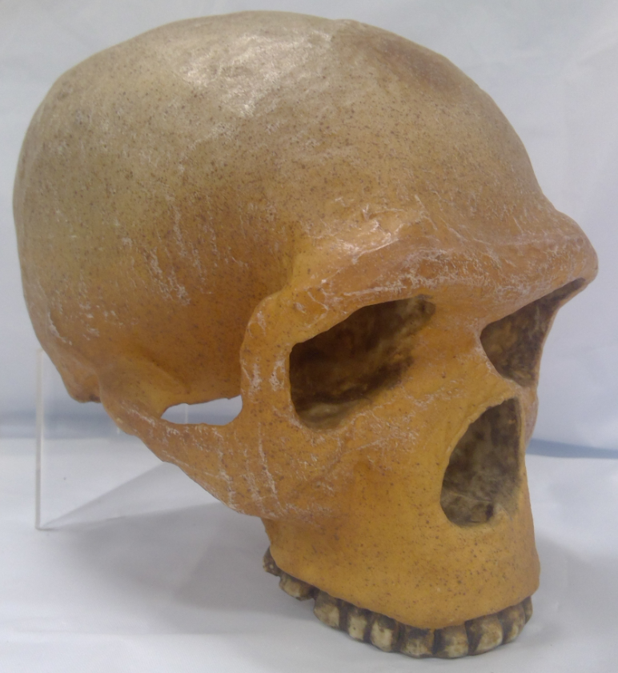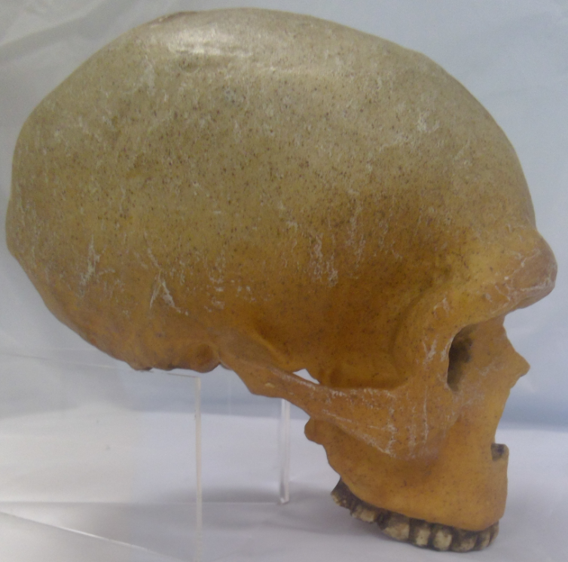

30. This species

(a) was known for hafting its tools.
(b) painted murals and made objects of art.
(c) was the first to utilise fire.
(d) produced the Aurignacian tool industry.

End of Section One
Section Two: Short answer 50% (100 Marks)

This section has five questions. Answer all questions. Write your answers in the spaces provided.

Supplementary pages for planning/continuing your answers to questions are provided at the end of this Question/Answer booklet. If you use these pages to continue an answer, indicate at the original answer where the answer is continued, i.e. give the page number.

Suggested working time: 90 minutes.

Question 31 (15 marks)

An AFL umpire was tested for his level of fitness by running on a treadmill in a laboratory held at 21ºC. While running, his breathing rate and heart rate increased and he produced a large volume of sweat.
(a) Which part of his brain would have controlled both his breathing and heart rate?
(1 mark)

Description | Marks
Medulla oblongata | 1
Total | 1

(b) His breathing rate increased during the fitness test.

(i) Name the product of cellular respiration that would have caused this change in breathing rate. (1 mark)

Description | Marks
Carbon dioxide | 1
Total | 1

(ii) Name the type of receptor that would have detected this stimulus and state where in the body these receptors are found. (2 marks)

Description | Marks
chemoreceptor | 1
Medulla oblongata / carotid and aortic bodies | 1
Total | 2

(iii) State the effectors in his body that would have increased his breathing rate.
(2 marks)

Description | Marks
Diaphragm | 1
Intercostal muscles | 1
Total | 2

(c) Account for the large volume of sweat that he produced during his test. (1 mark)

Description | Marks
Increased cell respiration / exercise produces large amounts of heat | 1
Total | 1

(d) During the fitness test it was noticed that the umpire’s core body temperature increased. Name the two main transfer mechanisms that would have allowed him to lose heat during the test and explain how each achieves a lower core body temperature. (8 marks)
Description | Marks
Evaporation | 1
Sweating onto the skin | 1
Evaporates / turns from liquid to gaseous state | 1
Which requires heat / removes heat from the body | 1
Radiation | 1
Without contact | 1
Heat is lost from high heat areas such as his body | 1
To low heat areas such as the room temperature environment | 1
Total | 8

Question 32 (19 marks)

The image below shows a nerve pathway.
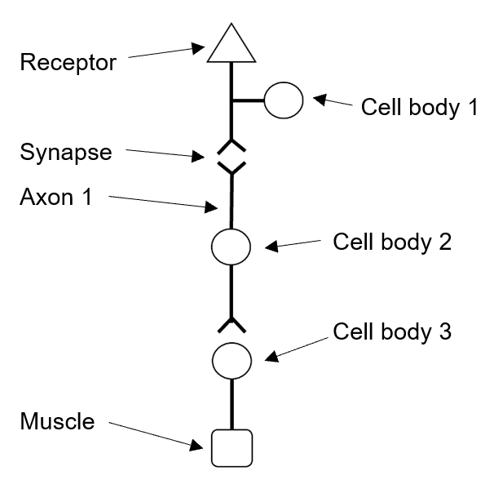
Figure 1
(a) The nerve pathway shown above can be considered to be a reflex arc. Use evidence from the image above to indicate why this might be the case. (2 marks)

Description | Marks
Three different types of neurons are included in the pathway | 1
A receptor is at one end and an effector / muscle at the other | 1
Total | 2

(b) Reflex arcs are known to be the fastest of all neural processes. Why can reflexes occur faster than all other neural processes? (1 mark)
Description | Marks
Messages do not travel to the brain before a response can be produced | 1
Total | 1

(c) Use the characteristics of how the systems function to explain why both nervous and endocrine methods of communication are required in the body. (4 marks)
Description | Marks
Nervous causes quicker responses which reduces chances of harm | 1-2
Nervous communication can target only specific cells / effectors | 1-2
Nervous communication does not last long so is good for short term effects | 1-2
Endocrine causes long lasting effects such as growth / puberty | 1-2
Endocrine can target a number of different target cells at the same time which ensures responses are coordinated | 1-2
Total | 4

(d) Where would cell body 2 in Figure 1 be found? (1 mark)
Description | Marks
Grey matter of the spinal cord | 1
Total | 1

(e) Explain the role neurotransmitters play in reflex arcs. (2 marks)
Description | Marks
Carry the nerve impulse as a chemical | 1
Across the synapse / from one neuron to another | 1
Total | 2

(f) If the muscle shown in the pathway is a skeletal muscle, which neurotransmitter would be involved in causing it to contract? (1 mark)
Description | Marks
acetylcholine | 1
Total | 1

(g) Explain the changes required for an action potential to occur. (4 marks)
Description | Marks
Outside of a neuron is positively charged, inside is negative | 1
A stimulus large enough to breach threshold | 1
Causes sodium gated channels to open and sodium to move in | 1
Which causes depolarisation of the neuron | 1
Total | 4

(h) A refractory period is part of all action potentials. Define the term refractory period and describe its purpose. (2 marks)
Description | Marks
Refractory period is when another action potential can’t begin | 1
Ensures nerve impulse travels in the desired direction | 1
Total | 1

(i) Dopamine is a neurotransmitter. Too much dopamine is associated with schizophrenia. One treatment for schizophrenia is to consume a drug that fills dopamine receptors on the post synaptic membrane. Explain how this drug might help to minimise the symptoms of schizophrenia. (2 marks)

Description | Marks
Drug blocks / prevents dopamine from attaching to the receptors | 1
Which prevents an action potential being transferred to the post synaptic neuron | 1
Total | 2

Question 33 (22 marks)
Since the beginning of January 2020 until the end of February 2021, an outbreak of coronavirus (COVID-19) has seen more than 114 million people infected and more than 2.5 million die from the disease globally. Numerous countries have worked tirelessly on developing a vaccine for the disease and there are currently a number of vaccines that have just recently been made available to the public. Sir Patrick Vallance, the UK’s chief scientific adviser said, “The miracle of the vaccines is extraordinary. We went from having no vaccine at all to having effective vaccines in a period of a year. That has never been done before for any other disease.”
The first study in England showed one dose of the Pfizer vaccine slashes the risk of hospitalisation and death by at least 75% among those aged over 80. Researchers looked at more than 12,000 people in this group in England after they were vaccinated to see if they fell ill, had to be admitted to hospital, or died. They were 57% less likely to develop symptomatic infection 28 days after the vaccination with a single dose, which increased to 88% after a second dose.
(a) What aspect of the methodology is improved by using more than 12,000 people in the study? (1 mark)
Description | Marks
Reliability | 1
Total | 1

(b) The more than 12,000 people who were vaccinated formed one group in the study.
(i) What is the name given to this group of people? (1 mark)

Description | Marks
Experimental group | 1
Total | 1

(ii) Describe the other group of people who would have made up this study.
(1 mark)
Description | Marks
People aged over 80 in England who did not have the vaccine | 1
Total | 1

(c) Explain why the elderly were less likely to develop symptomatic infection after the second dose of the Pfizer vaccine than they were after the first. (2 marks)
Description | Marks
The elderly had no memory cells at the time of the first dose so symptoms occurred | 1
Memory cells produced as a result of the first dose responded more quickly / more strongly to the infection after the second dose of vaccine (so no/fewer symptoms occurred) | 1
Total | 2

(d) Vaccines are usually tested extensively on animals prior to them being used in human trials. Describe the key ethical points researchers would have to be aware of prior to any animal testing taking place. (3 marks)

Description | Marks
Replacement of animals with other means wherever possible | 1
Reduction of number of animals used in the experiment | 1
Refinement of methodology to minimise harm to the animals | 1
Total | 3

(e) There are concerns in the community that people could develop COVID-19 as a result of them having been given the vaccine. With reference to sub-unit vaccines, explain why this is not a possibility. (3 marks)

Description | Marks
Sub-unit vaccines are made from only a portion/piece of an antigen | 1
So the antigen can’t reproduce | 1
And cause the symptoms associated with the disease | 1
Total | 3

(f) Some people have attended an anti-vaccine rally in Australia’s capital cities protesting against taking the vaccine. Give three reasons, other than thinking they may “catch” the disease from the vaccine, why people may not want to take the vaccine. (3 marks)

Description | Marks
Religious beliefs prevent it | 1-3
Cost may not be affordable | 1-3
Allergic to contents of vaccine | 1-3
Peer pressure / others in their circle aren’t vaccinating | 1-3
Risk of side effects | 1-3
Right to autonomous choice | 1-3
Total | 3

(g) What type of immunity is offered by the vaccine? (2 marks)

Description | Marks
Active | 1
Artificial | 1
Total | 2

At the same time, another disease, Buruli ulcer disease, appeared in and around Melbourne. A type of flesh-eating disease caused by a bacterium, Buruli ulcer disease has seen a large increase in incidence in the last few years. Studies show that the bacterium that causes the disease is also found in possums and mosquitoes.
(h) State three ways in which viruses and bacteria are different. (3 marks)

Description | Marks
Viruses are smaller than bacteria | 1-3
Viruses must reproduce inside a living cell while bacteria can reproduce by binary fission / themselves | 1-3
Viruses are not affected by antibiotics while bacteria can be killed by antibiotics | 1-3
Viruses can contain RNA or DNA while bacteria only contain DNA | 1-3
Viruses do not contain plasmids while bacteria do | 1-3
Viruses do not have a cell wall while bacteria do | 1-3
Viruses do not have a slime layer while bacteria do | 1-3
Total | 3

(i) Mosquitoes are believed to be the vector for this disease. What does this mean?
(1 mark)
Description | Marks
They transfer the antigen from one species to another without themselves being affected by the disease | 1
Total | 1

(j) Unlike COVID-19, Buruli disease can be treated with antibiotics. Explain how antibiotics affect bacteria. (2 marks)

Description | Marks
Change the structure of the cell wall / cell membrane which kills bacteria | 1-2
Stop bacteria from reproducing | 1-2
Disrupt essential enzymes of bacteria | 1-2
Disrupt protein synthesis | 1-2
Total | 2

Question 34 (12 marks)
The image below shows the types of mutation that can be found in humans.
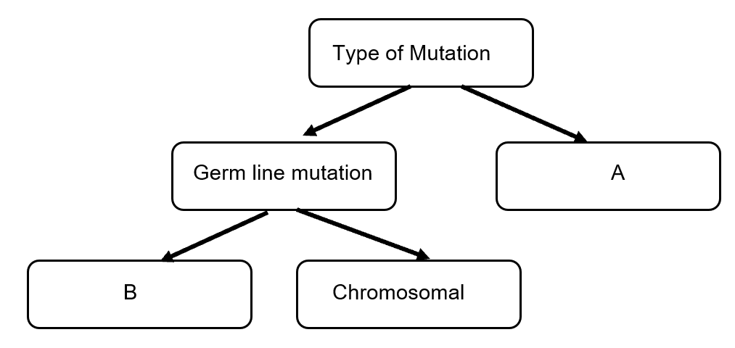
(a) State the type of mutation shown at A in the diagram above. (1 mark)
Description | Marks
Somatic | 1
Total | 1

(b) What does B in the diagram above represent? (1 mark)
Description | Marks
Gene mutations | 1
Total | 1

(c) State a difference between germ line mutations and the type of mutation shown at A.
(2 marks)
Description | Marks
Germ line mutations can be passed on to offspring | 1
Somatic mutations only affect the individual / do not affect offspring | 1
Total | 2

(d) Mutations can occur for a number of reasons. Explain how errors in DNA replication and cell division can result in mutations and give an example of a condition caused by each of these types of mutations. (4 marks)

Description | Marks
DNA replication
The double helix unwinds and copies of the two strands are made but a deletion / insertion / inversion / translocation / substitution occurs which alters the sequence | 1
Albinism / Duchenne muscular dystrophy / Tay Sachs / cystic fibrosis / other acceptable answers | 1
Cell division
Homologous chromosomes fail to separate / non-disjunction occurs | 1
Down syndrome / Klinefelter’s syndrome / Turners syndrome / other acceptable answers | 1
Total | 4

(e) Suggest how mutations affect the process of natural selection. (4 marks)

Description | Marks
Mutations contribute to variation in the gene pool of the population | 1
Which allows some organisms to be offered a survival advantage | 1
Or reduces their chances of survival | 1
When conditions change / when selection pressures are different | 1
Total | 4

Question 35 (19 marks)
Scientists investigated the effect of the concentration of carbon dioxide in air breathed by firefighters on their blood pH. They asked 5 firefighters to wear a full-face mask that was connected to a gas cylinder of varying carbon dioxide concentrations. During each test, the firefighters were asked to breathe normally and after 2 minutes, a finger prick test was conducted and their blood analysed to determine their blood pH. The scientists gave the firefighters a 1-minute rest between each gas test before commencing the next test. The scientists tested normal air (0.04% carbon dioxide), 0.08% and 0.12%.
(a) Write a hypothesis the scientists may have been testing. (2 marks)
Description | Marks
Eg: The higher the concentration of carbon dioxide in the air being breathed in, the lower the pH of the blood
Relationship between independent and dependent variable | 1
Direction of outcome indicated | 1
Total | 2

(b) Identify the dependent variable. (1 mark)
Description | Marks
Blood pH | 1
Total | 1

(c) Construct a table to show how these results would have been collated. (4 marks)
Description | Marks
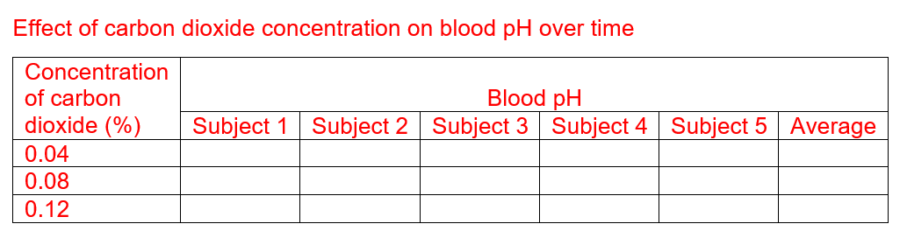

Title showing relationship between independent and dependent variable | 1
Columns with headings and units where applicable | 1
All trials shown | 1
Averages built into the table | 1
Total | 4

(d) The pH meter the scientists used could be set to give results to one or two decimal places. The scientists chose to receive their data to two decimal places. What have they improved? (1 mark)
Description | Marks
Accuracy | 1
Total | 1

(e) Explain how the scientists improved the reliability of their investigation. (2 marks)
Description | Marks
They used more than 1 subject / 5 subjects | 1
Which is a form of repetition | 1
Total | 2

(f) The results in this experiment may not have been valid. Using evidence, explain one factor that may have affected the validity and suggest how the scientists could improve the validity of their experiment. (3 marks)
Description | Marks
Time between tests was only 1 minute / very short | 1
Which may not have returned the pH of the blood to normal levels prior to the next test being conducted | 1
They could keep blood testing until a normal blood pH is reached prior to beginning the next test | 1
Total | 3

(g) Explain the relationship between carbon dioxide concentration and blood pH. (3 marks)
Description | Marks
Carbon dioxide combines with water to form carbonic acid | 1-2
Which breaks down to form hydrogen ions and bicarbonate ions | 1-2
Carbon dioxide is carried in the blood as bicarbonate ions | 1-2
Hydrogen ions determine blood pH | 1
Total | 3

(h) Before firefighters enter burning buildings, they will often unconsciously hyperventilate. Suggest how and why this may affect them. (3 marks)

Description | Marks
Hyperventilation greatly reduces the level of carbon dioxide in their blood but leaves oxygen levels relatively unchanged | 1
Exertion / physical activity uses up the oxygen before the urge to breathe is triggered | 1
Which could cause them to run out of oxygen and blackout in the building | 1
Total | 3

Question 36 (13 marks)
A group of archaeologists in South Africa were working on a series of core samples removed from one site. Their core samples are shown below.
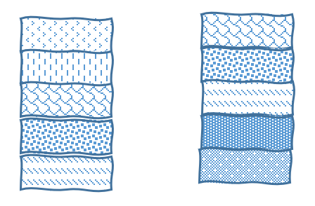
1 1
2 2
3 3
4 4
5 5
Core A Core B

(a) (i) Fossils were found in Core A layers 4 and 5 and it was determined that the
fossils found in layer 5 were older than those found in layer 4. State the dating method used to date these fossils. (1 mark)

Description | Marks
Principle of superposition / relative dating / stratigraphy | 1
Total | 1

(ii) Discuss two limitations of this method. (2 marks)
Description | Marks
Specimens must be found at the same location | 1-2
Can be affected by geological disturbances / faults / folding | 1-2
Can be affected by deliberate burial | 1-2
Total | 2

(b) Charles Darwin compared the fossil record to a book, a book with some pages and some words on each page missing. Explain why the fossil record may not be complete. (3 marks)
Description | Marks
Requires certain conditions / named condition to be met for fossilisation to occur | 1-3
Fossils must be undisturbed for a long period of time | 1-3
We don’t always look in the best places to find fossils | 1-3
Fossils may be buried too deep / not accessible | 1-3
Human activity / geological activity may have destroyed fossils | 1-3
Poor interpretation of fossils means we may not classify it correctly | 1-3
Total | 3

Mitochondrial DNA was extracted from the fossils taken from the two layers.
(c) Explain why mitochondrial DNA is more commonly used than nuclear DNA in investigations like these. (2 marks)

Description | Marks
More DNA is available in each cell | 1-2
It has a higher rate of mutation than nuclear DNA | 1-2
Shows relationships as it is inherited through the maternal line | 1-2
Total | 2

DNA sequencing of a gene from both sets of mitochondrial DNA was conducted in order to
compare them.

(d) The DNA from the two fossils (fossil 1 and fossil 2) as well as two potential close relatives (relative 3 and relative 4) were studied in order to determine the evolutionary relationships between the specimens. The table below shows a portion of the DNA sequence for the same gene from each specimen.
Table 1: DNA sequence for portion of one gene
 | DNA sequence in portion of one gene
Fossil 1 | A | A | C | G | T | T | G | A
Fossil 2 | A | A | C | C | T | T | A | A
Relative 3 | A | A | T | T | T | A | A | C
Relative 4 | A | C | G | A | C | G | C | T

(i) Name one gene on which this comparison could have been made. (1 mark)
Description | Marks
Cytochrome C / haemoglobin / other answers acceptable | 1
Total | 1

(ii) According to the table of DNA sequence data above, who is most closely related to fossil 1? (1 mark)
Description | Marks
Fossil 2 | 1
Total | 1

(iii) Construct a phylogenetic tree using the DNA sequence data in the table above. (3 marks)
Description | Marks
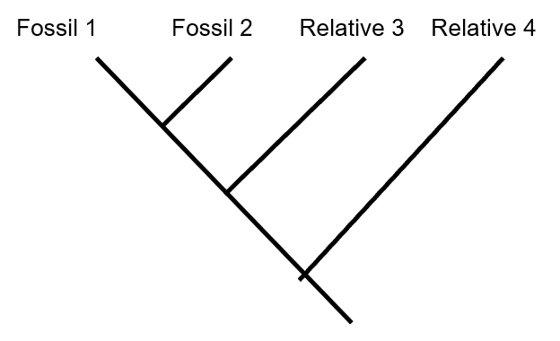
Fossil 1 and Fossil 2 most closely related | 1
Fossil 2 and Relative 3 more closely related than to Fossil 1 | 1
Relative 4 most distantly related to all other species | 1
Total | 1
End of Section Two
Section Three: Extended answer 20% (40 Marks)

Question 37 (20 marks)

(a) George was an active 5-year-old who enjoyed playing outside and kicking the ball with his older brother. One week, his mother noticed he lacked energy, had lost weight and was really thirsty all the time. At the doctor’s surgery, a blood test showed that George had diabetes.

(i) Use evidence to suggest which type of diabetes George is suffering from and describe the cause of this disease. (6 marks)

Description | Marks
He is suffering from Type I diabetes | 1
He is 5 years old | 1
The condition appeared very quickly / within a week | 1
Caused by genetics / autoimmune disease | 1
That destroys beta cells in the pancreas | 1
Which prevent insulin from being made and released | 1
Total | 6

(ii) Account for the symptoms George demonstrates and explain how this condition is normally treated. (6 marks)

Description | Marks
Lack of energy – cells are unable to access glucose | 1-5
So rate of cell respiration / cell processes is reduced | 1-5
Loss of weight – fat is broken down | 1-5
As an energy source for cell functioning | 1-5
Thirsty all the time – glucose levels in the blood are high so osmotic pressure in the blood increases | 1-5
ADH and thirst centre stimulated to reduce osmotic pressure | 1-5
Treated by insulin injection / insulin pump / insulin pen | 1
Total | 6

(b) Name a lipid-soluble hormone other than testosterone or aldosterone, explain how it alters cell functioning, identify its target cells and describe the specific effects of the named hormone on the body. (8 marks)

Description | Marks
Named lipid soluble hormone - Cortisol | 1
Explanation of how it alters cells functioning
Move through cell membrane | 1-4
Combine with receptor in cytoplasm / on mitochondria / organelle / inside nucleus / on gene | 1-4
Form a hormone receptor complex | 1-4
Activate genes | 1-4
Target cells
Fat cells | 1
All body cells | 1
Specific effects
Reduce inflammation | 1-2
Regulates blood glucose levels / converts fat to glucose / lipogenolysis | 1-2
Alleviates stress | 1-2
OR
Named lipid soluble hormone - Progesterone | 1
Explanation of how it alters cells functioning
Move through cell membrane | 1-4
Combine with receptor in cytoplasm / on mitochondria / organelle / inside nucleus / on gene | 1-4
Form a hormone receptor complex | 1-4
Activate genes | 1-4
Target cells
Uterus / endometrium | 1
Mammary glands | 1
Specific effects
Endometrium becomes more vascular and glandular | 1-2
Develops breast tissue during pregnancy | 1-2
Maintains pregnancy | 1-2
OR
Named lipid soluble hormone - Oestrogen | 1
Explanation of how it alters cells functioning
Move through cell membrane | 1-4
Combine with receptor in cytoplasm / on mitochondria / organelle / inside nucleus / on gene | 1-4
Form a hormone receptor complex | 1-4
Activate genes | 1-4
Target cells
Uterus | 1
breast | 1
ovary | 1
Specific effects
Thickening of the endometrium | 1-2
Breast development / secondary sex characteristics | 1-2
Total | 8

Question 38 (20 marks)

(a) Under extreme conditions, both ADH and aldosterone are required to regulate body fluid concentrations. Explain how these hormones maintain body fluid homeostasis. (12 marks)
Description | Marks
Osmotic pressure of blood increases / solute concentration increases | 1
Osmoreceptors in hypothalamus detect the increase in osmotic pressure | 1
Hypothalamus stimulates posterior pituitary gland | 1
To release ADH | 1
Which increases the permeability of the collecting tubule and distal convoluted tubule to water | 1
ACTHrf is released from the hypothalamus | 1
Which causes the anterior pituitary to release ACTH | 1
Which causes the adrenal cortex to release aldosterone | 1
Which targets the (ascending) loop of Henle / distal convoluted tubule | 1
Which increases the reabsorption of sodium into the blood | 1
Due to ADH more water is reabsorbed back into the blood | 1
So less water is lost as urine / osmotic pressure of the blood decreases | 1
Total | 12

(b) Compare and contrast the structure and function of multipolar and unipolar neurons. (8 marks)
Description |  | Marks
Comparison
Structure
Both have a cell body |  | 1
both have dendrites |  | 1
Both have axons / axon terminals |  | 1
Can be myelinated |  | 1
Function
Conduct nerve impulses |  | 1
Form part of the pathway in a reflex |  | 1
Contrast
Multipolar | Unipolar
Structure (Any 2 points, contrasted)
One axon exits cell body | One axon enters and leaves cell body | 1-4
Dendrites attached to cell body | Dendrites not attached to cell body | 1-4
Found in ventral root of spinal cord | Found in dorsal root of spinal cord | 1-4
Cell body in grey matter of spinal cord / cerebral cortex | Cell body in dorsal root ganglion | 1-4
Function (Any 1 point, contrasted)
Conduct away from CNS | Conduct towards CNS | 1-2
Are motor neurons | Are sensory neurons | 1-2
From CNS to effector / muscles / glands | From receptor to CNS | 1-2
Total |  | 8

Question 39 (20 marks)

(a) Tasmania has an incidence of 1/3000 of Huntington’s Chorea, a genetic condition, compared to an incidence of 1/10,000 in mainland Australia. Using the concepts of random genetic drift and founder effect, explain how this difference could have arisen. (6 marks)

Description | Marks
Population founding Tasmania do not show as much variation as the population founding Australia mainland | 1
A person with the Huntington’s Chorea allele migrated to Tasmania | 1
The small founding population in Tasmania thus contained this allele | 1
Inbreeding between individuals in the small population occurred / the population had a limited gene pool | 1
Due to geographical isolation | 1
By chance / through random genetic drift, this condition became more common | 1
Total | 6

(b) Piltdown Man is a well-known fossil found in 1912 by Charles Dawson, an amateur collector. It was made up of nine pieces of a human-like large brained skull and an ape-like jaw with two teeth. Its find was believed to support the concept of ‘the missing link’ – a fossil that showed the relationship between apes and humans.
(i) Contrast the jaw and teeth of great apes and hominins. (6 marks)

Description |  | Marks
(Any 3 points, contrasted)
Great Apes | Hominins | 1-6
U shaped jaw | Parabolic jaw | 1-6
Simian shelf | No simian shelf | 1-6
prognathic | Flat faced / orthognathic | 1-6
Canines large and projecting | Canines similar in size and shape to other teeth | 1-6
Pre-canine diastema | No pre-canine diastema | 1-6
No chin | Chin present | 1-6
Large molars and premolars | Molars and premolars similar in size and shape to other teeth | 1-6
Total |  | 6

(ii) Describe how carbon 14 dating works and explain how it could have determined that the Piltdown Man was, in fact, a fake. (8 marks)

Description | Marks
C14 is produced by the action of radiation on nitrogen in the atmosphere | 1
When organisms die they stop taking in C14 | 1
Age of a fossil is determined by the ratio of C14 to C12 | 1
C14 has a half life of 5730 years | 1
So the ratio of C14:C12 decreases over time | 1
So can date fossils up to 70,000 years | 1
Dating the skull pieces and the jaw with C14 should show all the fossils to be the same age9 | 1
As it was a fake, the jaw must have been a different age to the skull bones | 1
Total | 8

Question 40 (20 marks)

(a) Tay Sachs is a fatal and incurable genetic disease that occurs in the world at a rate of about 1 in 400,000. In some populations, however, it occurs in 1 in 3600 births and, in these same populations, the incidence of being a carrier for the disease occurs at a rate of 1 in 30. Explain, using the concept of heterozygote advantage, why Tay Sachs is so much more common in some populations than in others. (6 marks)

Description | Marks
Individuals with two recessive alleles for Tay Sachs die | 1
Individuals with two dominant alleles suffer from tuberculosis and may die | 1
Heterozygotes do not suffer from Tay Sachs and have a greater resistance to tuberculosis | 1
In those populations affected by tuberculosis, heterozygotes have a survival advantage and are able to reproduce | 1
Thus passing on either the dominant or recessive allele to their offspring | 1
In this way, the recessive allele offers a survival advantage if only one copy is present in the genome | 1
Total | 6

(b) Homo sapiens and Homo neanderthalensis both existed at the same time in some parts of the world and are believed to share a common ancestor approximately 500,000 years ago.
(i) Suggest why the two species would have originated. (8 marks)

Description | Marks
All individuals in the common ancestor population would have shown variation | 1-8
More individuals would be born than could survive to maturity | 1-8
If groups of common ancestors became isolated from each other | 1-8
In the environment there would have been different selective forces | 1-8
Which would result in a struggle for existence in each group | 1-8
The well adapted individuals would survive and reproduce | 1-8
And the key features that aided survival would be passed on | 1-8
While the less adapted individuals would die / not reproduce as successfully | 1-8
Over time each population would become more alike within the population and more different to the other population | 1-8
So when their differences became so large they would not be able to interbreed with each other, speciation would occur | 1-8
Total | 8

(ii) Discuss how and why bioinformatics and the polymerase chain reaction would have been used as part of this research. (6 marks)

Description | Marks
PCR would have been used to make multiple copies of the DNA | 1
That would have been extracted from the fossil species | 1
As only small amount of DNA would have been able to be collected | 1
Bioinformatics combines computer science, statistics, mathematics to analyse large amounts of biological data such as DNA sequences | 1
Determines the similarity between the species in specific genes | 1
Which can then determine the degree of evolutionary relatedness between species | 1
Total | 6

End of questions

ACKNOWLEDGEMENTS

Q. 15
https://unsplash.com/photos/A9pxMWzlfW0
https://unsplash.com/@sofiaken/collections
rock art

All other images are author’s own.

